**YouTube tutorial 70 – Cool Program based on File Structuring**

https://www.youtube.com/watch?v=86rBqzYIbjA&index=70&list=PLAE85DE8440AA6B83

#include "stdafx.h"

#include <iostream>

#include <fstream>

#include <string>

using namespace std;

//Get Input through this

int getWhatTheyWant() {

int choice;

cin >> choice;

return choice;

}

//Display Items

void displayItems(int a) {

ifstream inFile("objects.txt");

string name;

int number;

if (a == 1) {

while (inFile >> name >> number) {

if (number == 0) {

cout << name << ' ' << number << endl;

}

}

}

if (a == 2) {

while (inFile >> name >> number) {

if (number > 0) {

cout << name << ' ' << number << endl;

}

}

}

if (a == 3) {

while (inFile >> name >> number) {

if (number < 0) {

cout << name << ' ' << number << endl;

}

}

}

}

//Main Function

int main()

{

cout << "1 - Print plain items" << endl;

cout << "2 - Print useful items" << endl;

cout << "3 - Print useless items" << endl; //Gives instructions

cout << "4 - Quit the program" << endl << endl;

while(true){

int localVariable; //Since I couldn't change an instance variable inside

localVariable = getWhatTheyWant(); //while loop, I used local variable

displayItems(localVariable);

if (localVariable == 4) { break; } //break while loop if the variable is 4

cout << endl;

}

}**Result:**

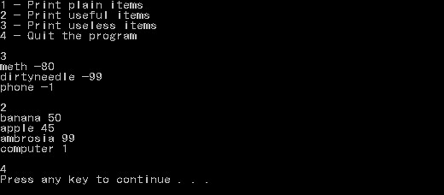

**File being read (objects.txt):**

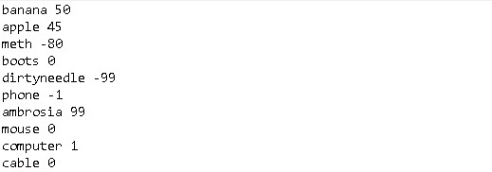

**Important notes:**